Ex5.1:
searchStudents(String keyword) method:
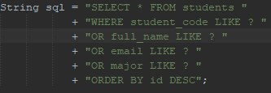
This SQL query searches 4 columns:
- student_code
- full_name
- email
- major
it uses “like” so partial matches are allowed. “ORDER BY id DESC” means newest students will appear first.
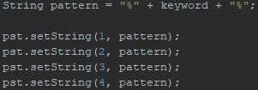
This warps the keyword with % to allow partial matching and sets the same pattern for all 4 search fields.
Automatically closes:
- Connection
- PreparedStatement
- ResultSet
Prevents memory leaks
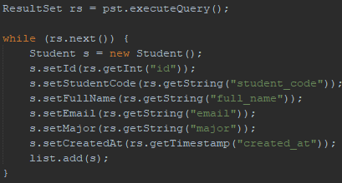
executeQuery() sends the SQL to the database.
The “while” loop iterates through each matching row.
A new “Student” object is created for every row.
All column values are extracted and set using getters.
The student is added to the result “List<Student>”
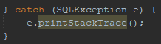
If the query fails, it prints the stack trace.
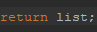
This gives the controller a list of all matching students.

Ex5.2:
searchStudents(request, response) method:
Gets whatever the user typed into the search bar.
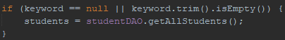
If nothing is typed, all students will be listed.
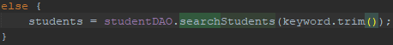
Calls the DAO to find students whose “code”, “name”, “email”, or “major” contain the keyword.
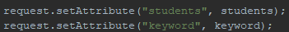
Stores data for JSP so that the JSP can show results and keep the search text in the input field.
Renders the same student list page, but with filtered result.

Ex5.3:
“action = search” => triggers “searchStudent()” method
method= “get” => search appears in URL
Whatever user types becomes “request.getParameter(“keyword”)”.
The “value” keeps the text after searching => ${keyword} is set by the controller.
Submits the form => triggers search logic.
Uses JSTL <c:if> to show this link “only if” a “keyword” exists.
Clicking resets the page by calling “student?action=list”.

Ex6.1:
private boolean validateStudent(Student student, HttpServletRequest request):
- Student code
- Must not be null or empty.
- Must match 2 uppercase letters + ≥3 digits (e.g., SV001, IT123)
- On failure: request.setAttribute("errorCode", "...")
- Full Name
- Must not be null or empty
- Minimum 2 characters
- On failure: request.setAttribute("errorName", "...")
- Email
- Only checked if not empty
- Must match basic email format
- On failure: request.setAttribute("errorEmail", "...")
- Major
- Must not be null or empty
- On failure: request.setAttribute("errorMajor", "...")
Workflow:
- Start “isValid = true”
- Check each field
- If a field fails => set error message in request + “isValid = false”
- Return “isValid”
This allows the controller to:
- Forward back to the form if “false”
- Preserve user input and show specific field errors

Ex6.2:
private void insertStudent(HttpServletRequest request, HttpServletResponse response):
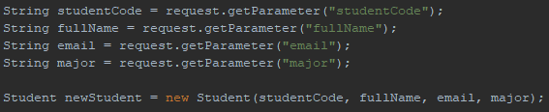
Reads input from the form and creates a new “Student” object.
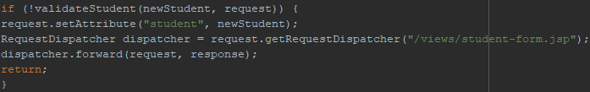
- Calls “validateStudent()”
- If any validation fails:
- Set the student object as a request attribute (request.setAttribute("student", newStudent)) so the form keeps user input.
- Forward back to the JSP form (dispatcher.forward(...))
- Stops execution immediately with return.
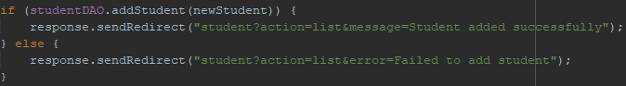
- If validation passed, calls DAO to insert into the database.
- Redirects to the list page with success or error message depending on DAO result.

private void updateStudent(HttpServletRequest request, HttpServletResponse response):
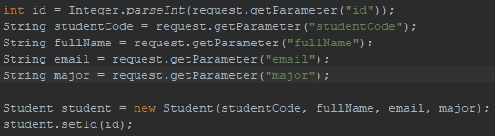
- Reads input from the form including the hidden “id”.
- Creates a “Student” object and sets its “id”.
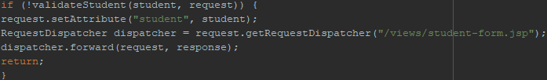
- Validates the student.
- On failure, preserves data and returns to the form, exactly like “insertStudent()”.
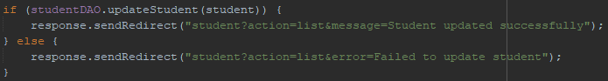
- Calls DAO to update the database.
- Redirects to list page with feedback message.

Ex6.3:
- Student code
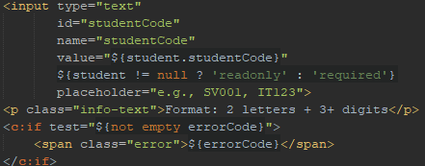
- Shows the existing value (${student.studentCode}) if editing.
- Makes the field readonly for edit mode (student != null) and required for new insert.
- Displays error message from “validateStudent()” if “errorCode” exists.
- Full Name
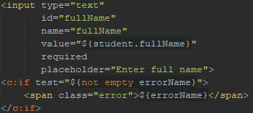
- Shows entered or existing value.
- Error message appears if “validateStudent()” sets “errorName”.
- Email
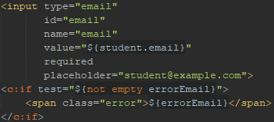
- Pre-fills the email field.
- Displays error if the email format is invalid (errorEmail).
- Major
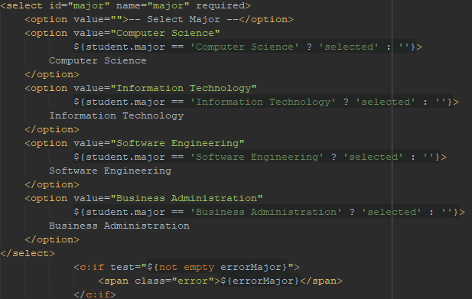
- Preserves the previously selected major.
- Shows an error message if validation fails “errorMajor”.

Ex7.1:
- public List<Student> getStudentsSorted(String sortBy, String order):
- Returns a list of students sorted by the specified column “sortBy” and direction “order”.
- Validates parameters:
+ “sortBy” must be one of: "id", "student_code", "full_name", "email", "major".
+ “order” must be "asc" or "desc".
+ Defaults: sortBy = "id", order = "asc" if invalid.
- Executes query, maps “ResultSet” to “Student” objects, returns the list.
- public List<Student> getStudentsByMajor(String major):
- Returns all students in a specific major.
- Uses PreparedStatement to prevent SQL injection.
- Sets the major parameter, executes query, maps “ResultSet” to “Student” objects.
Ex7.2:
private void sortStudents(HttpServletRequest request, HttpServletResponse response):
- request.getParameter("sortBy") => reads the column to sort by.
- request.getParameter("order") => reads ascending or descending order.
- Calls DAO method:
- Sets attributes for JSP to render the sorted table:
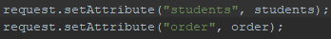
- Forwards to the JSP:
private void filterStudents(HttpServletRequest request, HttpServletResponse response):
- Reads the selected major:
- Calls DAO:
- Handles edge case for “All Majors” (empty selection):
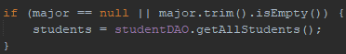
- Sets attributes for JSP:
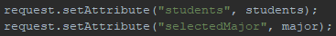
- Forwards to the JSP to render the filtered table:

Ex8.1:
public int getTotalStudents():
- Purpose: Count all student records in the database.
- SQL: SELECT COUNT(*) FROM students
- Logic:
+ Executes the query.
+ Uses “rs.getInt(1)” to retrieve the first column of the result (the count).
+ Returns the total number of students.
- If an exception occurs, it prints the stack trace and returns 0.
- Use case: Needed to calculate the total number of pages for pagination.
public List<Student> getStudentsPaginated(int offset, int limit):
- Purpose: Fetch a subset of students for a specific page.
- SQL: SELECT * FROM students ORDER BY id DESC LIMIT ? OFFSET ?
+ LIMIT => number of records per page.
+ OFFSET => starting position of records (calculated from current page).
- Logic:
+ Sets the “limit” and “offset” parameters in the “PreparedStatement”.
+ Executes the query.
+ Loops through the “ResultSet” to populate “Student” objects.
+ Returns a “List<Student>” containing only the students for that page.
- Use case: Used by the controller to show paginated results and to display “Next”/“Previous” pages.

Ex8.2:
private void listStudents(HttpServletRequest request, HttpServletResponse response):
- Default to page 1.
- Try parsing “pageParam”. If invalid (e.g., non-numeric), fall back to 1.
- Each page will show 10 students.
- “getTotalStudents()” counts all students in the DB.
- “totalPages” = ceiling of total records ÷ records per page.
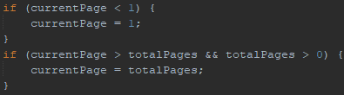
- Ensures “currentPage” is never less than 1 or greater than the total number of pages.
- Determines starting row for the current page.
- Only retrieves students for the current page using “LIMIT” and “OFFSET”.
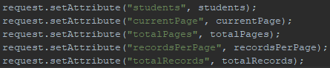
- Sends student list + pagination info to “student-list.jsp”.
- The JSP uses these attributes to display the table and pagination UI.

Ex8.3:
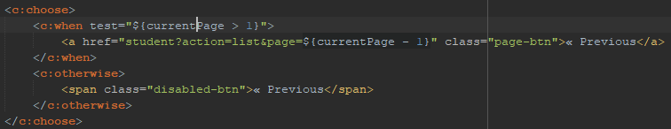
- Enabled only if “currentPage” > 1.
- Otherwise, shows a disabled span.
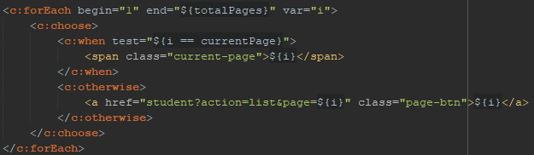
- Loops from 1 to “totalPages”.
- Highlights the current page (<span class="current-page">) and makes others clickable links.
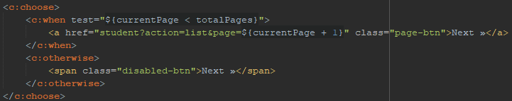
- Enabled only if “currentPage” < “totalPages”.
- Disabled when on the last page.
- Displays a simple "Showing page X of Y" message.

